Lab experiment #3

**Adding Vectors and Equilibrium of Forces**

**Pre-lab questions**

1. What is the goal of this experiment? What physics and general science concepts does this activity demonstrate to the student?
2. What are the methods of vector addition?

The goal of the experiment is to study vector addition by the parallelogram method and the component method, and then use the force table to model the results.

**Introduction**

A **scalar** quantity is a number that has only a magnitude. When scalar quantities are added together (e.g., prices), the result is a sum.

**Vectors** are quantities that have both magnitude and direction; speciﬁc methods of addition are required. Many physical properties, like forces, are described by vectors. When vector quantities are added, the result is again a vector. For example, if you walk 1 mile north, then 1 mile east, you will walk a total distance of 2 miles (*distance is a scalar* quantity). *Displacement, a vector*, involves both distance and direction. So the same 2 mile walk results in a displacement of $\sqrt{2}$ miles northeast of where you began.

A negative vector has the same length as the corresponding positive vector, but with the opposite direction. Making a vector negative can be accomplished either by changing the sign of the magnitude or by simply adjusting the direction by 180°.

**Addition of Vectors**

*Parallelogram method:* Vectors can be added together graphically by drawing them end-to-end. A vector can be moved to any location; so long as its magnitude and orientation are not changed, it remains the same vector. When adding vectors, the order in which the vectors are added does not change the resultant; vector addition is commutative.

* 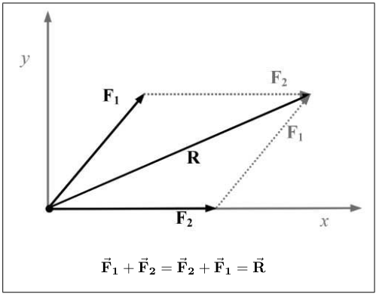Draw each vector on a coordinate system; begin each from the origin.
* Choose any vector drawn to be the ﬁrst vector.
* Choose a second vector and redraw it, beginning from the end of the ﬁrst.
* Repeat, adding as many vectors as are desired to the end of the “train” of vectors.
* The resultant is a vector that begins at the origin and ends at the tip of the last vector drawn. It is the shortest distance between the beginning and the end of the path created.

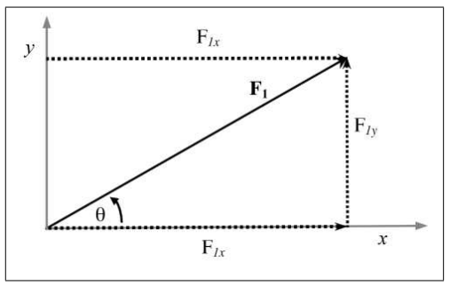*Component Method:* To add vectors by components, calculate how far each vector extends in each Cartesian dimension. The lengths of the *x*- and *y*-components of a vector depend on the length of the vector and the sine or cosine of its direction angle, *θ*, measured counterclockwise from the positive *x*-axis.:

$F_{1x}=\left|F_{1}\right|cosθ, F_{1y}=\left|F_{1}\right|sinθ$.

When each vector is broken into components, add the *x*-components of each vector to get the *x*-component of the resultant:

$F_{1x}+F_{2x}+…=\sum_{i=1}^{n}{F_{ix}}=R_{x}$.

Then, add the *y*-components of each vector to get the *y*-component of the resultant:

$F_{1y}+F_{2y}+…=\sum_{i=1}^{n}{F_{iy}}=R_{y}$.

These sums are the *x*- and *y*-components of the resultant vector, **R**. Since these vector components form the sides of a right triangle, the magnitude of this resultant vector is obtained by applying the Pythagorean rule: $R=\sqrt{R_{x}^{2}+R_{y}^{2}}$. And the direction angle, *φ*, of the resultant vector **R** is obtained from the ratio of these Cartesian components via the trig definition: $φ=\tan^{-1}\left({R_{y}}/{R_{x}}\right)$. [Note: A calculator will only give one of two possible angles satisfying this function. Use basic physical reasoning, i.e., common sense, to figure out which is the correct answer – look at whether *R*x and/or *R*y are positive or negative to see which quadrant the angle should be in.]

**Force Table Addition of Forces**

**Equipment**: Force table, center ring, 3 pulleys, thread and scissors, 3 mass hangers, set of masses, ruler and protractor. (Note: Some force tables may be slightly different.)

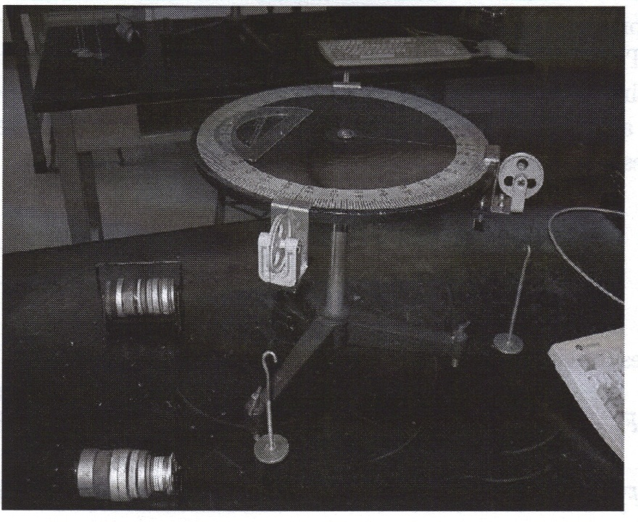

In this experiment you will use a force table to compare the calculated sum of two forces, **F**1 and **F**2, with the force table model. A force table is shown in Figure 1.

Figure . A force table with the pulleys, weight hangers and slotted masses.

You will be hanging masses off of the force table via the pulleys to create forces on the center ring. The edge of the table is marked with angle graduations to measure the direction of the force vector. Because mass, *m*, is a scalar, it needs to be multiplied by the acceleration of gravity, *g* = 9.81m/s2, to find the magnitude of the force it is exerting on the ring, |**F**| = *mg* (notice this comes from Newton’s second law of motion). Be sure to use SI units in your calculations; when mass has units of kg, which is then multiplied by m/s2 from the acceleration giving kg-m/s2 =N (Newtons), the unit for force.

1. Using a bubble level where appropriate, check that the force table is level. Check that the center pin is securely holding the centering ring in place on the force table.
2. Positioning the pulleys appropriately around the edge of the force table, and using mass hangers with slotted masses for each, set up forces **F**1 and **F**2 on the force table (magnitude and angle). Suggested: The pulleys for **F**1 and **F**2 may be located between 30° and 140° apart, while the respective masses, including hanger, may be between 20 g and 100 g.
3. By either graphical (parallelogram) or component methods, find the resultant force **R** = **F**1 + **F**2. This resultant force would tend to pull the center ring in the direction indicated at a goodly acceleration. However, the situation changes if an equilibrant force, **E** = -**R** is added on the force table. The net force acting on the center ring is then **F**1 + **F**2+ **E** = **R** + **E** = 0, as **E** = -**R**. Check your result by pulling the pin from the center ring. (Tapping the surface of the force table lightly is suggested, in case one of the pulleys may stick a bit.) If it worked, the ring should just stay in place.

**Results and Conclusions**

**Sources of Error**

**Questions:**

1. If five vectors were added tail-to-tip and they ended up where they started from, what would be the magnitude and direction of the resultant **R**?
2. Is the graphical or force table method more accurate? Why?